A PROJECT ON

OPEN SOURCE TECHNOLOGY
Submitted In Partial
Fulfilment For The Degree Of
Bachelor OF Computer
Application
Submitted By
Miss Dipika Vijay Shelar
Under The Guidance Of
Miss. Neha Thorat

SNDT Women’s University, Mumbai
BACHELOR OF COMPUTER APPLICATION
Regal College Of Technology
Kondhe- Chiplun Dist-Ratnagiri
(2024-2025)

CERTIFICATE

This is certify that the project report entitled,
Open Source Technology
Has been successfully completed & it embodies the
Genuine & Original work submitted by,
Miss. Dipika Vijay Shelar
In the Partial Fulfilment of requirement of
BACHELOR OF COMPUTER APPLICATION

Miss. Neha Thorat Mrs. Vaishali Bhosale
(Project Guide) (H.O.D)

Date:30/4/2025

Project for
Open Source Technology

This is to certify that Miss Dipika Vijay ShelarFrom F.Y.BCA. Of Regal College Of Technology has successfully completed her project work titled “Open Source Technology” under my guidance and direction.

GUIDE CERTIFICATE
This is a bona-fide work carried out during the academic year 2024-25 towards partial fulfilment of the Bachelor of Computer Application (BCA) degree course offered through honourable University of SNDT of Mumbai.
Throughout the project, she was found sincere, regular and hard working.

Authorized Signature
Miss. Neha Thorat
(Regal College Of Technology,
Kondhe Chiplun)

Acknowledgement

It’s my great pleasure to take this opportunity and sincerely thanks
all those, who have showed me the way to successful project and help
me a lotduring the completion of my project.
I greatly thank my Project Guide Miss.Neha Thorat without whom
The completion of this project couldn’t have been possible.
I take this Opportunity to express my deep gratitude towards
All the members of the Information Technology Department, for helping me in the completion of the project.
My sincere thanks to respected director Dr. Sumita Shirke for availability of Computer lab for 24 hours.
Further I thank to all my colleagues for their encouragement & support
Throughout the period of completion.

Miss.Dipika Vijay Shelar.
F.Y.BCA (Bachelor of Computer Application)

Index

Sr.No | Title | Page No
1 | Introduction | 6
2 | Current System | 7
3 | Advantages Of The Proposed System | 8
4 | Objective & Scope of proposed system | 10
5 | Hardware, Software, Requirement | 11
6 | Coding | 12
7 | Output | 24
8 | Future Enhancement | 31
9 | References Bibliography | 32

Introduction

- Open source technology refers to software or hardware whose design is publicly accessible, allowing anyone to view, use, modify, and distribute the source code or schematics.

- Open source development is characterized by a collaborative and public approach, where developers and users can contribute to the software's improvement and evolution.

- GitHub is a web-based platform used for version control and collaborative software development. It is built around Git, an open source distributed version control system.

- GitHub hosts repositories (projects) where developers can store, share, and collaborate on code.

- It supports both public (open source) and private (restricted access) repositories.

- It provides tools for issue tracking, pull requests, code reviews, CI/CD, and project management.

Current systems
In the current system, most websites related to musical instruments are commercial or closed platforms. They provide limited access to content and do not allow users to interact with or contribute to the website's development. Additionally, the source code is not shared publicly, and there is no use of open-source platforms like GitHub. This restricts transparency, learning, and community collaboration. Users cannot suggest changes, report bugs directly in code, or learn from the website’s structure.

Advantages of Proposed System

In the existing system, the entire project is uploaded to GitHub, a cloud-based platform for hosting code and collaborating with others. It may also be deployed using GitHub Pages for public viewing.

Advantages of the proposed System:
- Version Control (via Git):
  - Tracks every change made to the project.
  - Allows rollback to previous versions if errors occur.
- Remote Backup:
  - Project is stored in the cloud, reducing the risk of data loss.
- Collaboration:
  - Others can view, fork, and contribute to the project using pull requests.
  - Issues and discussions can be used to track suggestions and improvements.
- Free Web Hosting (via GitHub Pages):
  - Host the website online without paying for a server.
  - Share the live project easily using a GitHub Pages link.
- Professional Visibility:
  - Showcase your project in portfolios, resumes, or to potential employers.
- Open Source Sharing:
  - Encourages learning and reuse by others who may benefit from your work.

Objectives and Scope
Objectives:
•Promote Transparency and Trust
- Make source code and designs openly accessible to ensure transparency and build trust among users and developers.
•Encourage Collaboration and Community Involvement
- Enable individuals and organizations worldwide to contribute, improve, and innovate collectively.
•Enhance Learning and Knowledge Sharing
- Provide free access to code and documentation for educational purposes and skill development.
•Accelerate Innovation
- Allow faster experimentation, adaptation, and integration of new features or technologies.
•Reduce Cost and Vendor Lock-in
- Offer cost-effective alternatives to proprietary software and prevent dependence on single vendors.
•Ensure Flexibility and Customization
- Allow users to modify the software according to specific needs or local requirements.

Scope:
- Software Development
  - Operating systems (e.g., Linux), web browsers (e.g., Firefox), frameworks (e.g., React), and programming languages (e.g., Python).
- Hardware Design
  - Open source hardware like Arduino, Raspberry Pi, and open CPU architectures (e.g., RISC-V).
- Education and Research
  - Academic institutions and students use open source tools for learning, research, and innovation.
- Web Development and Hosting
  - Platforms like GitHub and GitLab for source code management and GitHub Pages for hosting.
- Data Science and AI
  - Libraries like TensorFlow, Scikit-learn, and Jupyter Notebooks enable accessible machine learning development.
- Government and Public Services
  - Governments adopt open source for transparency, cost savings, and digital sovereignty.
- Business and Enterprise Use
  - Enterprises adopt open source technologies to build scalable, cost-effective solutions.

Hardware software requirement

Hardware :

- System-Multimedia PC
- Processor-Intel(R) Pentium(R) CPU G2030 @ 3.00GHz 3.00 GHz
- Hard Disk-80 GB or above

Software :

- Operating System-Microsoft Windows 10
- Web browser-Google chrome
- Front End -VS Code

CODING
1.Welcome page
<!doctype html>
<html>
<body bgcolor="pink">
<br>
<br>
<br>
<br>
<br>
<br>
<br>
<h1 align="center"> || WEL-COME || <h1>
<h6 align="center"><a href="C:\Users\REGAL-DP\Desktop\SUMENA\flowers name.html" name="s3"> Next</a></h6>
</body>
</html>

2.Home Page
<!doctype html>
<html>
<head>
<style>
body{
background-image:url(i7.webp);
background-repeat:no-repeat;
background-attachment:fixed;
background-size:100% 100%;
}
h1{color:black}
h4{;color:white;font-size:22px}
p{color:white;font-size:20px}
a{font-size:23px;text-decoration:none}
</style>
</head>
<body><br><br>
<nav>
<a href="C:\Users\REGAL-DP\Desktop\f.y.website\home page.html">ABOUT US | </a>
<a href="C:\Users\REGAL-DP\Desktop\f.y.website\destination 2.html">DESTINATIONS |</a>
<a href="C:\Users\REGAL-DP\Desktop\f.y.website\feedback.html">FEEDBACK FORM</a>
</nav>
<br><br>
<h1 align="left">DREAMS TIME TRAVEL AGENCY</h1>
<h4>Adventure in the world</h4>
<p>Unleash you inner explorer with captivating <br> travel adventure around the world Embrance<br>new experiences and create Lasting memories.<br>Travelling ;it leaves you speechless, then turns into a storyteller.</p>
</body>
</html>

3.About Us

<!Doctype html>
<html><head>
<style>
body{
background-image:url(sky2.jpg);
background-repeat:no-repeat;
background-attachment:fixed;
background-size:100% 100%;
}
</style>
</head>
<body>
<h1 align="center"><b>ABOUT DREAMES TIME TRAVEL </b></h1>
<p align="center"> Founded in 2012 in India, Dreams Time has grown from a small Dutch start-up to one of the world’s leading digital travel companies. Dreams Time's mission is to make it easier for everyone to experience the world.By investing in technology that takes the friction out of travel, Dreams Time seamlessly connects millions of travelers to memorable experiences, a variety of transportation options, and incredible places to stay – from homes to hotels, and much more. As one of the world’s largest travel marketplaces for both established brands and entrepreneurs of all sizes, Dreams Time enables properties around the world to reach a global audience and grow their businesses.<br>
Dreams Time is available in 43 languages and offers more than 28 million reported accommodation listings, including over 6.6 million homes, apartments, and other unique places to stay. Wherever you want to go and whatever you want to do, Dreams Time makes it easy and supports you with 24/7 customer support.<p><br>
<h1>What Dreams Time Offers</h1>
<ul>
<li><h3>Incredible Selection :</h3>
<p>Whether you want to stay in a chic city apartment, a luxury<br> beach resort, or a cozy B&B in the countryside, Dreams Time<br> gives you amazing diversity and variety of choice – all in one place.</p></li>
<li><h3>Low Rates :</h3>
<p>Dreams Time guarantees to offer you the best available rates.<br> And with our promise to price match, you can rest assured that<br> you’re always getting a great deal.</p></li>
<li><h3>Instant Confirmation :</h3>
<p>At Dreams Time, every reservation is instantly confirmed.<br> When you find your perfect stay, a few clicks are all it takes.</p></li>
<li><h3>No Reservation Fees :</h3>
<p>We don’t charge you any booking fees or add any administrative<br> charges. And in many cases, your booking can be canceled free of charge.</p></li>
<li><h3>Secure Booking :</h3>
<p>We facilitate hundreds of thousands of transactions every day through our<br> secure platform and work to the highest standards to guarantee your privacy. </p></li>
<li><h3>24/7 Support :</h3>
<p>Whether you’ve just booked or are already enjoying your trip,<br> our Customer Experience Team is available around the clock to answer your<br> questions and advocate on your behalf in more than 40 languages.</p></li>
<h3 align="center"><a href="C:\Users\REGAL-DP\Desktop\f.y.website\second page.html">Back</a></h3>
</body>
</html>

4.Destination Page
<!doctype html>
<html>
<head>
<style>
h1{font-family:Forte}
h2{font-family:David}
body{text-align:center}
body{
background-image:url(blueimage.jpg);
background-repeat:no-repeat;
background-attachment:fixed;
background-size:100% 100%;
}
tr{border-style:solid;border-width:8px}
</style>
</head>
<body bgcolor="lightyellow">
<h1 align="center"><b><u>|| TOP TRAVEL DESTINATION || </u></b></h1>
<table border="5">
<tr>
<td><br>
<img src="C:\Users\REGAL-DP\Desktop\f.y.website\london bridge.jpg" alt="i1" height="110%" width="65%"></a><br>
<h2><b>London</b></h2>
<p>Travel and find happiness within yourself. Allow us to convince you. You won't regret it. Find the best time to go and the best places to visit for a true London experience. Travel Information. Cheap and Fun Travel. Sustainable Tourism.</p><br>
<p>_______________________________________</p>
<a href="C:\Users\REGAL-DP\Desktop\f.y.website\london.html" name="third page"><input type="button" value="Explore"></a> <a href="C:\Users\REGAL-DP\Desktop\f.y.website\form.html" name="third page"><input type="button" value="Registration Form"></a>
</td>
<td><br>
<img src="C:\Users\REGAL-DP\Desktop\f.y.website\agra.webp" alt="i2" height="75%" width="75%"></a><br>
<h2><b>India</b></h2>
<p>One of the best reasons to visit India lies in its nature. From north to south and east to west, India is blessed with natural beauty in abundance.From Andamans to Kerala to Pondicherry, there are numerous places to visit in India where you can witness nature in its best form.</p>
<p>_______________________________________</p>
<a href="C:\Users\REGAL-DP\Desktop\f.y.website\india.html" name="p2"><input type="button" value="Explore"></a> <a href="C:\Users\REGAL-DP\Desktop\f.y.website\form.html" name="third page"><input type="button" value="Registration Form"></a>
</td>
<td><br>
<a href="" name="p7"><img src="C:\Users\REGAL-DP\Desktop\f.y.website\paris arc de triomphe.jpg" alt="i3" height="90%" width="90%"></a><br>
<h2><b>Paris</b></h2>
<p>Paris has many cultural assets. It has more than 2,000 monuments, such as the Eiffel Tower, the Sacré-Cœur and Notre-Dame. The Louvre is one of the largest museums in the world, where you can see the Mona Lisa, by Leonardo da Vinci.</p>
<p>_______________________________________</p>
<a href="C:\Users\REGAL-DP\Desktop\f.y.website\paris.html" name="third page"><input type="button" value="Explore"> <a href="C:\Users\REGAL-DP\Desktop\f.y.website\form.html" name="third page"><input type="button" value="Registration Form"></a>
</td>
</tr>
<tr>
<td><br>
<img src="C:\Users\REGAL-DP\Desktop\f.y.website\italo pome.jpg" alt="i1" height="70%" width="70%"></a><br>
<h2><b>Italli</b></h2>
<p>Italy is well-known for its architecture, culture, art, opera, literature, film, and fashion. This is one of the best countries to go on a foreign tour. The country is known for its mesmerizing topography, pristine beaches, historical artifacts, monuments, and more.</p>
<p>_______________________________________</p>
<a href="C:\Users\REGAL-DP\Desktop\f.y.website\itali.html" name="third page"><input type="button" value="Explore"> <a href="C:\Users\REGAL-DP\Desktop\f.y.website\form.html" name="third page"><input type="button" value="Registration Form"></a>
</td>
<td>
<br>
<img src="C:\Users\REGAL-DP\Desktop\f.y.website\dubai burj.jpg" alt="i1" height="88%" width="88%"></a><br>
<h2><b>Dubai</b></h2>
<p>Dubai's strong reputation is matched by its top rank in the Business & Investment pillar, with the city perceived as having the second-best strong and stable economy and the highest future growth potential.</p>
<p>_______________________________________</p>
</a><a href="C:\Users\REGAL-DP\Desktop\f.y.website\dubai.html" name="third page"><input type="button" value="Explore"> <a href="C:\Users\REGAL-DP\Desktop\f.y.website\form.html" name="third page"><input type="button" value="Registration Form"></a>
<td>
<br>
<img src="C:\Users\REGAL-DP\Desktop\f.y.website\brazil cristo.jpg" alt="i1" height="88%" width="88%">
<h2><b>Brazil</b></h2>
<p>Christ the Redeemer is one of Brazil's most iconic landmarks. This massive statue of Jesus Christ overlooks Rio de Janeiro from the top of Corcovado Mountain.</p>
<p>_______________________________________</p>
<a href="C:\Users\REGAL-DP\Desktop\f.y.website\brazil.html" name="third page"><input type="button" value="Explore"> <a href="C:\Users\REGAL-DP\Desktop\f.y.website\form.html" name="third page"><input type="button" value="Registration Form"></a>
</td>
</tr>
</table>
<h3 align="center"><a href="C:\Users\REGAL-DP\Desktop\f.y.website\second page.html">Back</a></h3><br>
</body>
</html>

5.London Page
<!doctype html>
<html>
<head>
<style>
aside{float:right;width:800px}
body{
background-image:url(4.jpg);
background-repeat:no-repeat;
background-attachment:fixed;
background-size:100% 100%;
}
</style>
</head>
<body>
<header>
<h1 align="center"><u><b><i>LONDON</i></b></u></h1>
<p>London, the capital of England and the United Kingdom, is a 21st-century city with history stretching back to Roman times. At its centre stand the imposing Houses of Parliament, the iconic ‘Big Ben’ clock tower and Westminster Abbey, site of British monarch coronations. Across the Thames River, the London Eye observation wheel provides panoramic views of the South Bank cultural complex, and the entire city. </p>
</header>
<article>
<h1><b>Best Places To Visit in London : </b></h1>
</article>
<aside>
<p>The Tower of London, officially His Majesty's Royal Palace and Fortress of the Tower of London, is a historic castle on the north bank of the River Thames in central London, England. Wikipedia</p>
<ul>
<li>Address: London EC3N 4AB, United Kingdom</li>
<li>Built: White Tower: 1078; Inner ward: 1190s; Rebuilt: 1285; Wharf expansion: 1377–1399</li>
<li>Hours:
Closed ⋅ Opens 10 am</li>
<li>Height: 27 metres (89 ft)</li>
<li>Area: Castle: 12 acres (4.9 ha); Tower Liberties: 6 acres (2.4 ha)</li>
<li>Phone: +44 333 320 6000<.li>
<li>Visitors: 2,790,280 (in 2023)</li>
<li>London borough: London Borough of Tower Hamlets</li>
<li>UNESCO Site Id: 488
<li>Owner: King Charles III in right of the Crown
</ul>
</aside>
<section>
<h1><b>1.Tower of London</b></h1>
&nbsp;&nbsp;&nbsp;&nbsp;&nbsp;&nbsp;&nbsp;&nbsp;&nbsp;&nbsp;&nbsp;&nbsp;&nbsp;<img src="C:\Users\REGAL-DP\Desktop\f.y.website\london tower.webp" name="n1" height="20%" width="20%" align="center">
<br><br>
</section><br>
<aside><br>
<p>Buckingham Palace is a royal residence in London, and the administrative headquarters of the monarch of the United Kingdom. Located in the City of Westminster, the palace is often at the centre of state occasions and royal hospitality. </p>
<ul>
<li>Address: London SW1A 1AA, United Kingdom
<li>Owner: John Sheffield, 1st Duke of Buckingham and Normanby
<li>Architects: William Winde, Aston Webb, John Nash, Edward Blore
<li>Function: Palace, Official residence
<li>Opened: 1705
<li>Height: 24 m
<li>Phone: +44 303 123 7300" name="n1" height="20%" width="20%" align="center">
</ul>
</aside>
<article>
<h1><b>2.Buckingham Palace</b></h1>
&nbsp;&nbsp;&nbsp;&nbsp;&nbsp;&nbsp;&nbsp;&nbsp;&nbsp;&nbsp;&nbsp;&nbsp;&nbsp;<img src="C:\Users\REGAL-DP\Desktop\f.y.website\buckingham palace.jpg" name="n1" height="20%" width="20%" align="center">
<br>
<br>
</article>
<aside><br>
<p>The Natural History Museum in London is a museum that exhibits a vast range of specimens from various segments of natural history. It is one of three major museums on Exhibition Road in South Kensington, the others being the Science Museum and the Victoria and Albert Museum.</p>
<ul>
<li>Address: Cromwell Rd, South Kensington, London SW7 5BD, United Kingdom
<li>Stories from the collection: Mythical creatures: unicorns · See more
<li>Hours:
Closed ⋅ Opens 10 am
<li>Founded: 1881, South Kensington, London, United Kingdom
<li>Architect: Alfred Waterhouse
<li>Phone: +44 20 7942 5000
<li>Director: Doug Gurr
</ul>
</aside>
<section>
<h1><b>3.Natural History Museum</b></h1>
&nbsp;&nbsp;&nbsp;&nbsp;&nbsp;&nbsp;&nbsp;&nbsp;&nbsp;&nbsp;&nbsp;&nbsp;&nbsp;<img src="C:\Users\REGAL-DP\Desktop\f.y.website\natural history museum.jpeg" name="n1" height="20%" width="20%" align="center">
<br><br>
</section><br>
<aside><br>
<p> The name "London Bridge" refers to several historic crossings that have spanned the River Thames between the City of London and Southwark in central London since Roman times. The current crossing, which opened to traffic in 1973, is a box girder bridge built from concrete and steel.</p>
<ul>
<li>Address: London EC4R 3TN, United Kingdom
<li>Location: London, City of London, Southwark, Central London, SE postcode area
<li>Construction started: 1967
<li>Body of water: River Thames
<li>Opened: 17 March 1973
</ul>
</aside>
<article>
<h1><b>4.London Bridge</b></h1>
&nbsp;&nbsp;&nbsp;&nbsp;&nbsp;&nbsp;&nbsp;&nbsp;&nbsp;&nbsp;&nbsp;&nbsp;&nbsp;<img src="C:\Users\REGAL-DP\Desktop\f.y.website\london bridge.jpg" name="n1" height="20%" width="20%" align="center">
<br>
<br>
</article>
<aside><br>
<p>Kensington Palace Gardens is an exclusive street in Kensington, west of central London, near Kensington Gardens and Kensington Palace. Entered through gates at either end and guarded by sentry boxes, it was the location of the London Cage, the British government MI19 centre used during the Second World War and the Cold War.</p>
<ul>
<li>Address: Kensington Gardens, London W8 4PX, United Kingdom
<li>Hours:
Closed ⋅ Opens 10 am Wed
<li>Opened: 1605
<li>Architects: Christopher Wren, Nicholas Hawksmoor
<li>Function: Palace
<li>Owner: King Charles III in right of the Crown
<li>Architectural style: Jacobean architecture
<li>Phone: +44 333 320 6000
</ul>
</aside>
<section>
<h1><b>5. Kensington Palace and Garden</b></h1>
&nbsp;&nbsp;&nbsp;&nbsp;&nbsp;&nbsp;&nbsp;&nbsp;&nbsp;&nbsp;&nbsp;&nbsp;&nbsp;<img src="C:\Users\REGAL-DP\Desktop\f.y.website\london palace.jpg" name="n1" height="20%" width="20%" align="center">
<br><br><br>
</section><br>
<h1 align="center"><a href="C:\Users\REGAL-DP\Desktop\f.y.website\destination 2.html">BACK</a></h1>
</body>
</html>

6.Registartion Form
<!doctype html>
<html>
<head>
<style>
body{
background-image:url(2.jpg);
background-repeat:no-repeat;
background-attachment:fixed;
background-size:100% 100%;
}
</style>
</head>
<body>
<h1 align="center"><b>REGISTRATION FORM</b></h1>
<table align="center">
<tr>
<td><h3>Traveler Name :<br><input type="text" value="First"maxlenght="50" > <input type="text" value="Last"></h3></td>
</tr>
<tr><td colspan="2"><h3>Birth Date :<br><input type="date" value="MM/DD/YYYY"maxlenght="50"></h3></td> </tr>
<tr><td colspan="2"><h3>Email :<br><input type="text" maxlength="20"></h3></td> </tr>
<tr> <td colspan="2"><h3>Cell Phone :<br><input type="text" value="### ### ####" maxlength="50"></h3></td> </tr>
<tr><td colspan="2"><h3>Address :<br><input type="text" value="Street Address" maxlength="20"><br><input type="text" value="City" maxlength="20"><br><input type="text" value="Zip Code"><br><input type="text" value="Country"></h3></td> </tr>
<tr> <td colspan="2"><h3>Special Request :<br><input type="text" maxlength="20"></h3></td> </tr>
<tr><td colspan="2"><h3><a href="C:\Users\REGAL-DP\Desktop\f.y.website\second page.html"name="third"><input type="button" value="REGISTER" maxlength="20"></a></h3></td> </tr>
</table>
</body>
</html>

7.Feedback Form
<!DOCTYPE html>
<html lang="en">
<head>
<meta charset="UTF-8">
<meta name="viewport" content="width=device-width, initial-scale=1.0">
<title>Feedback Form</title>
<style>
body{
background-image:url(8.webp);
background-repeat:no-repeat;
background-attachment:fixed;
background-size:100% 100%;
}
body {
font-family: Arial, sans-serif;
background-color: #f9f9f9;
padding: 40px;
}
.container {
max-width: 500px;
margin: auto;
background-color: #fff;
padding: 30px;
border-radius: 10px;
box-shadow: 0 0 10px rgba(0,0,0,0.1);
}
input, textarea, select, button {
width: 100%;
padding: 10px;
margin: 10px 0;
border: 1px solid #ccc;
border-radius: 5px;
}
button {
background-color: #4CAF50;
color: white;
font-weight: bold;
cursor: pointer;
}
button:hover {
background-color: #45a049;
}
</style>
</head>
<body>

<div class="container">
<h2>Feedback Form</h2>
<form action="#" method="post">
<label for="name">Your Name:</label>
<input type="text" id="name" name="name" required>

<label for="email">Your Email:</label>
<input type="email" id="email" name="email" required>

<label for="rating">How would you rate us?</label>
<select id="rating" name="rating">
<option value="excellent">Excellent</option>
<option value="good">Good</option>
<option value="fair">Fair</option>
<option value="poor">Poor</option>
</select>

<label for="message">Your Feedback:</label>
<textarea id="message" name="message" rows="5" required></textarea>

<button type="submit" onclick="feedback()"><a href="thank you.html" name="immage">Submit</a></button>
</form>
</div>
<!-- <script>
function feedback(){
alert("Thank You for submitting the form...");
}
</script> -->
</body>
</html>

13.Thank You
<!doctype html>
<html>
<head>
<style>
body{
background-image:url(2.jpg);
background-repeat:no-repeat;
background-attachment:fixed;
background-size:100% 100%;
}
</style>
</head>
<body>
<br><br><br><br><br><br><br><br><br><br><br><br><br><br><br><br><br><br><br><br><br><br><br><br><br><br><br><br><br><br><br>
<h3 align="right"><a href="C:\Users\REGAL-DP\Desktop\f.y.website\welcome.html"name="d1">Home Page</a></h3>
</html>

Output

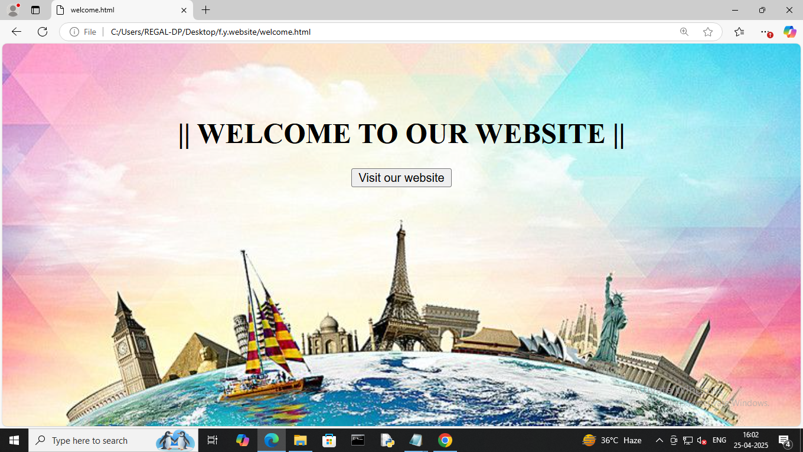

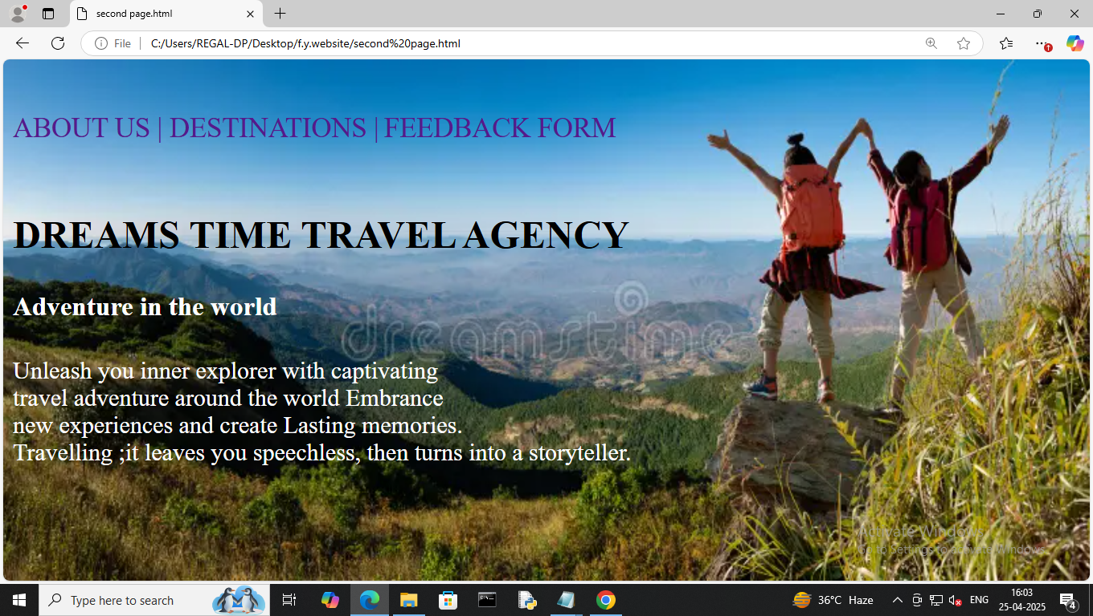

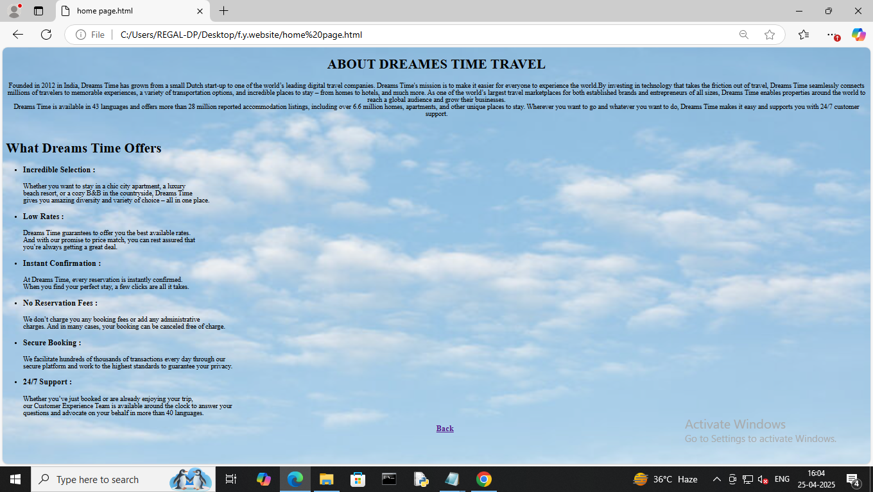

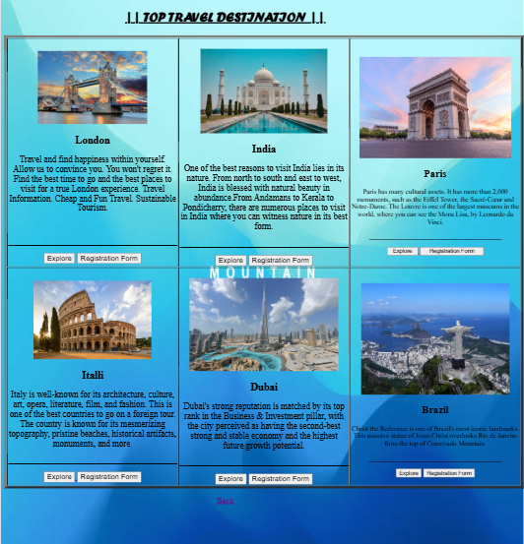

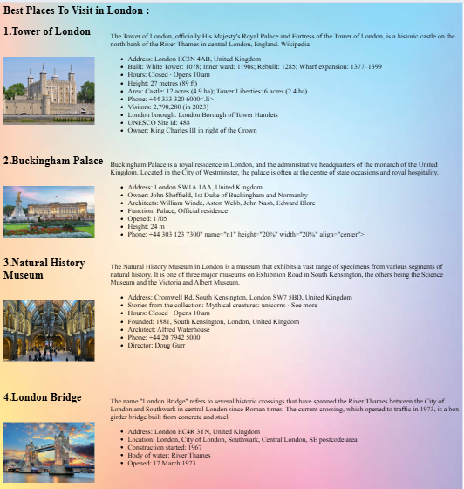

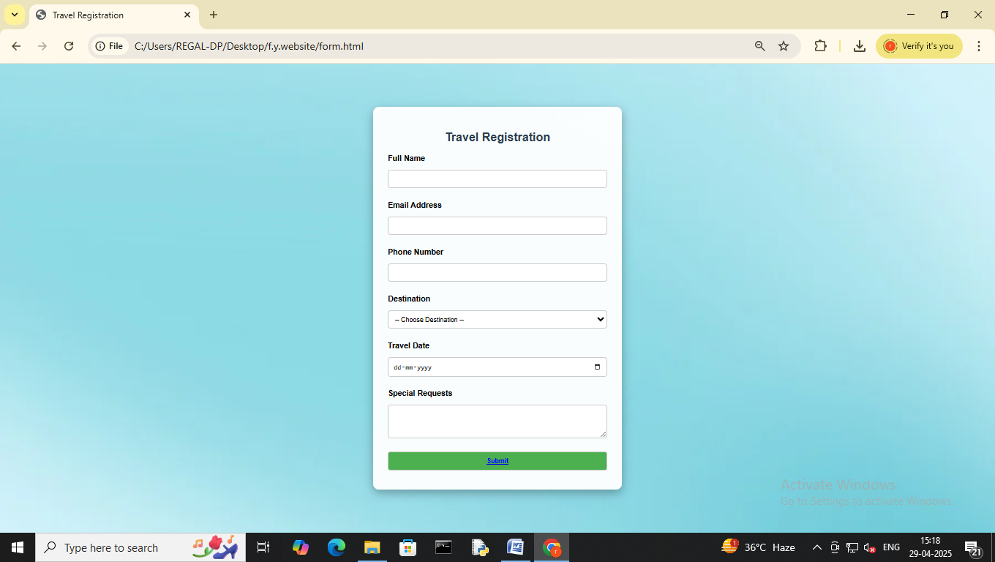

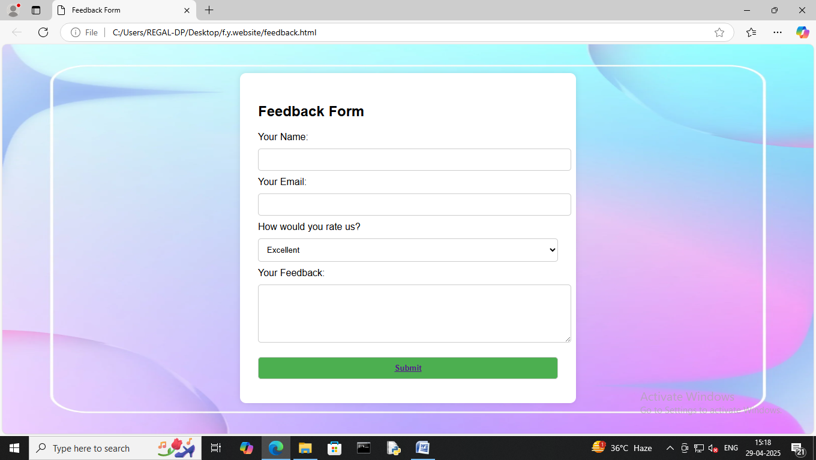

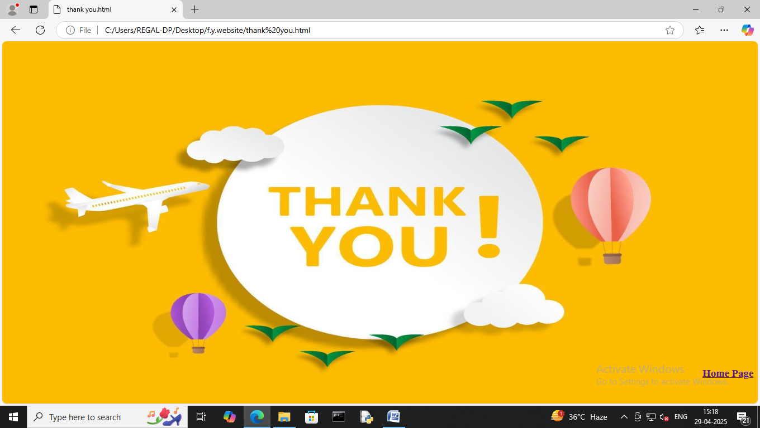
Project Uploaded on Github:

Future Enhancement

- Enhanced Documentation Tools: Open source projects may adopt better standards for writing and structuring documentation. AI-assisted tools for generating and maintaining documentation could also become common.

- Improved User Interfaces (UIs): Open source software will continue to focus on providing better, more intuitive user experiences, especially for non-developers, to broaden the user base.

- Improved GitHub/GitLab Features: We can expect more robust project management tools integrated within platforms like GitHub and GitLab, including advanced project tracking, code quality checks, and automated workflows.

References Bibliography

- https://www.bajaao.com/
- https://www.symphonymusic.online/
- https://www.furtadosonline.com/?srsltid=AfmBOoqRVlWmZZ6r8MMgQV_-9O-lPWXF-3CqWzMnxFa76mnGGcne2bnn
- https://www.musicianscart.com/?srsltid=AfmBOorYCdB7-MIt8dT1wZhR0GdSrjZ1sbhiA7gLoMrHsFnq6VHk519r
- https://docs.github.com/en
- https://www.musicca.com/tools
- https://yamahamusicstore.in/?srsltid=AfmBOop8uQ6ezNk6aKvfgshb1Pc3UoH81Pr2UHfCr-87DKCD29YZfO4b

